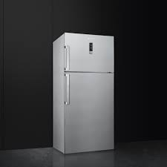

SMEG

* Fast Freezing, ECO
* Voltage (V): 220-240 V
* Color Stainless Steel
* Type Of Shelves: Glass
* **Rs.67,000**